Name: | SOLUTIONS |  |  | Date: ___________
 | Year 9 Mathematics  Test 3, 2015  Topics – Surface Area and Volume |  |  | 55  = %
Total Time: | 60 minutes
Total Reading: | 5 minutes
Total Working: | 55 minutes
Weighting: | ______% of the year.
SECTION 1: CALCULATOR FREE
Time: | 19 minutes | Marks for Section 1: | 17
Reading: | 2 minutes | Equipment Allowed: | Nil
Working: | 17 minutes

1. | [4 marks]
 | Explain the difference between surface area and volume. Use a rectangular prism to help you explain.
The surface area of a solid is found by adding the area of each of the outside surfaces of the solid. It is measured in ‘squared’ units, as it is a two-dimensional quantity. ✓

To help calculate surface area, it is often useful to draw the ‘net’ of the solid – a flat, two-dimensional diagram that shows each of the surfaces. The surface area of this rectangular prism is the sum of the area of each of the 6 rectangular faces. ✓

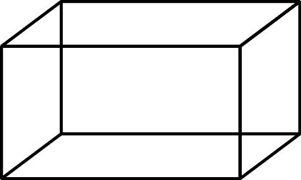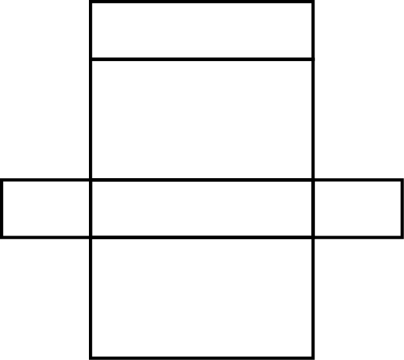

The volume of a solid is the three-dimensional space taken up by the solid. It is measured in ‘cubed’ units. ✓
The volume of this rectangular prism is the area of the base multiplied by the height. ✓

2. | [2 marks: ½, ½, ½, ½ ]
Use words from the list below to complete the following sentences.

height rectangular prism capacity area base volume surface area

a) | ___Capacity___ is another word for volume . ½✓
b) | The general formula for finding the volume of a prism is the area of the ______base______ multiplied by the ________height______ . ½✓
c) | The _____area_____ of a shape is the two-dimensional space inside it. ½✓
d) | The volume of a __rectangular prism__ is found by multiplying the length by the width by the height. ½✓

3. | [2 marks: ½, ½, ½, ½]
 | Match the solids below with their corresponding nets:
 | 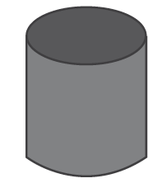 | ○ |  | ○ | 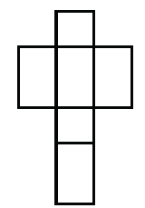½✓
 | 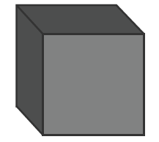 | ○ |  | ○ | 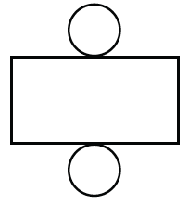½✓
 | 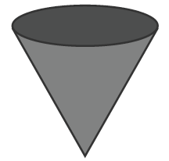 | ○ |  | ○ | 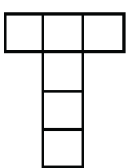½✓
 | 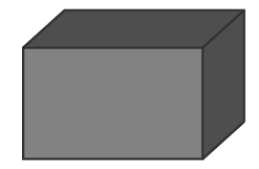 | ○ |  | ○ | 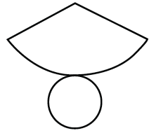½✓

4. | [5 marks: 2, 3]
 | What is the surface area of the following shapes formed from the nets shown?
a) | Cube: | b) | Triangular prism:
 | 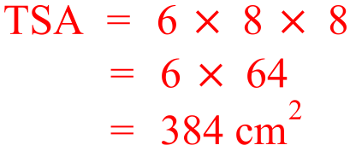  ✓  ✓ | 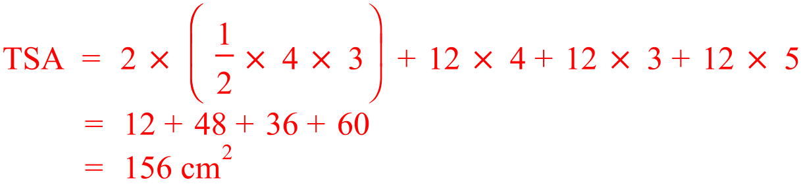  ✓✓  ✓

5. | [4 marks: 2, 2]
 | Determine the volume of the following prisms:
a) |  | b)
 | 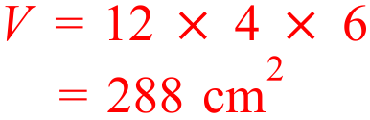  ✓  ✓ |  | 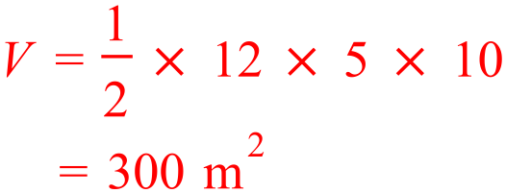  ✓  ✓

~ END OF TEST SECTION 1 ~
Name: | ___________________________________________________ |  |  | Date: ___________
SECTION 2: CALCULATOR ASSUMED
Time: | 41 minutes | Marks for Section 2: | 38
Reading: | 3 minutes | Equipment Allowed: | ½ page notes (A4 one side), Scientific calculator
Working: | 38 minutes

6. | [10 marks: 3, 3, 4]
 | Find the surface area of the following solids:
a) | 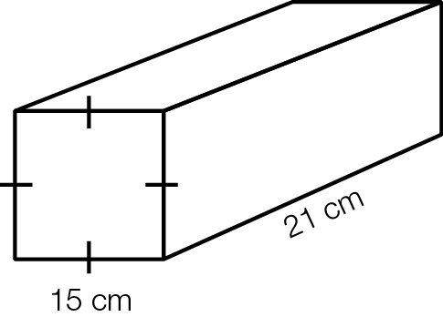 | b) | 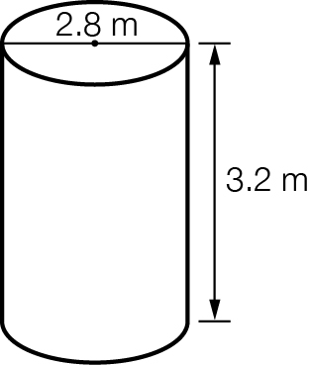
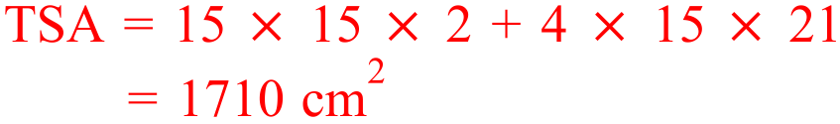  ✓✓  ✓ |  | 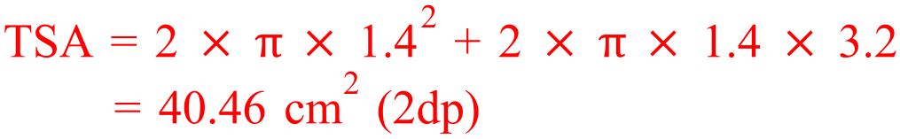  ✓✓  ✓
c) | 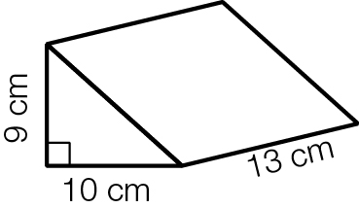  Hint: You will need to use Pythagoras.
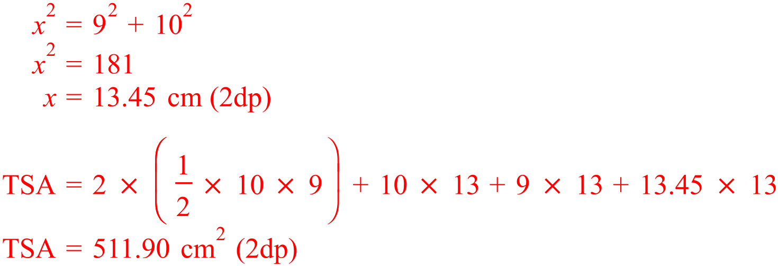

✓

✓✓
✓

7. | [7 marks: 1, 1, 2, 3]
 | Determine the volume of the following prisms:
a) |  | b)
 | 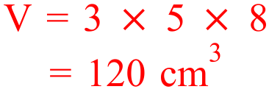 ✓ |  | 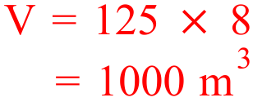 ✓
c) |  | d)
 | ✓  ✓  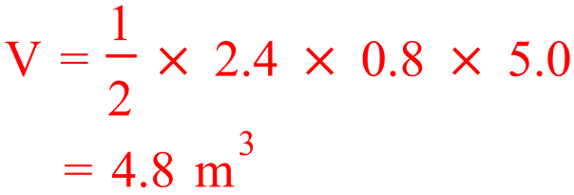 |  | 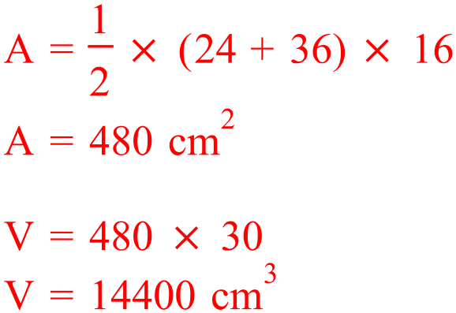  ✓  ✓  ✓

8. | [2 marks]
An advertising sign for Hayman Island is in the shape of the island and is 5 cm thick.
The sign is made of wood and has an area of 850 cm².
What volume of wood is in the sign?
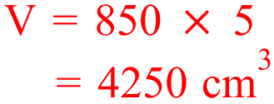

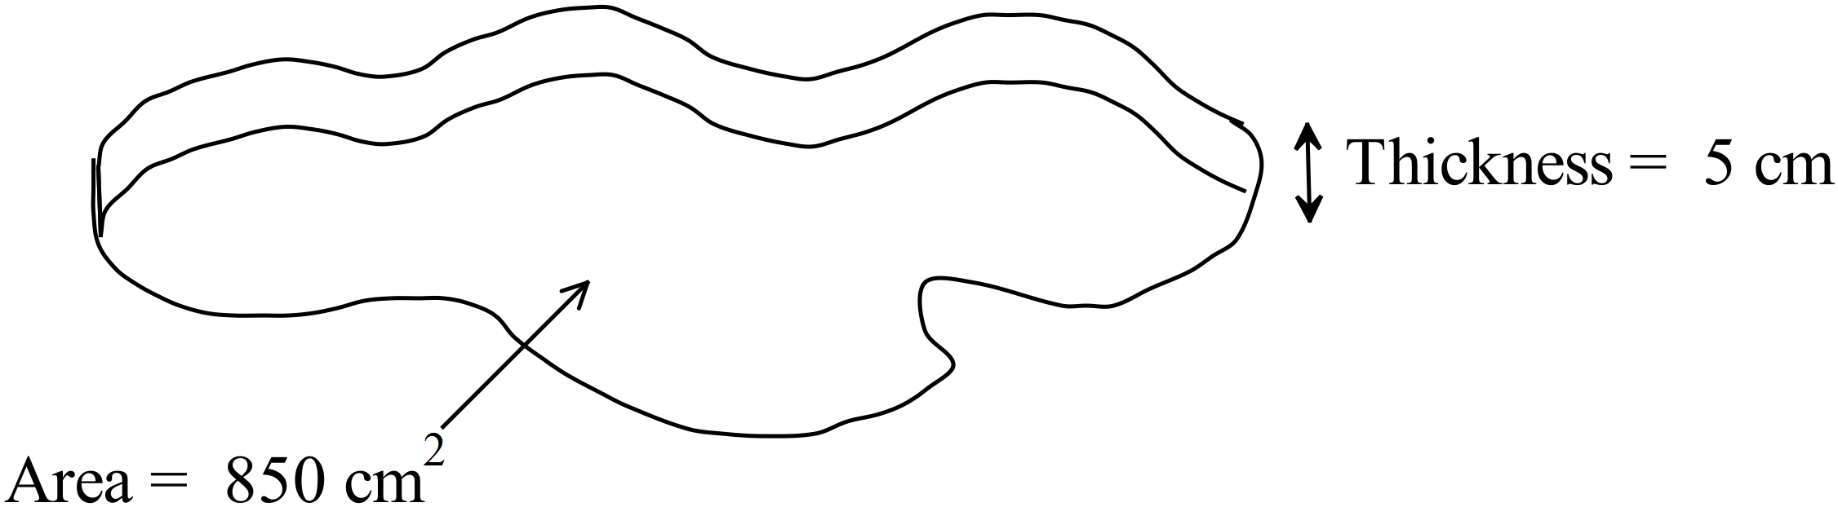
✓
✓

9. | [3 marks]
Find the volume of the concrete needed to make this hollow pipe, correct to two decimal places.
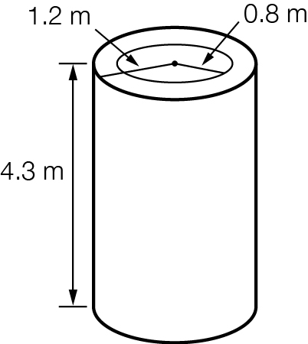

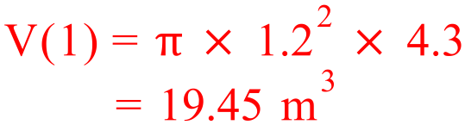 ✓

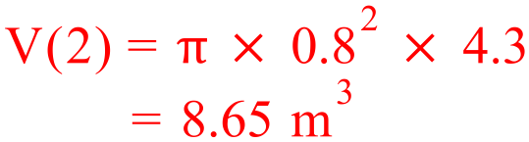 ✓

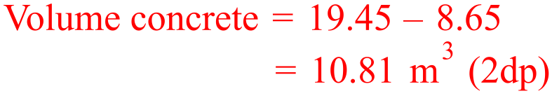 ✓

10. | [4 marks]
 | Farmer Stan has built a drinking trough for his new sheep by cutting a cylindrical drum in half. If the drum had a diameter of 6 m and height of 16m, how much water can the drinking trough hold? Draw a diagram to help you answer the question.
 | 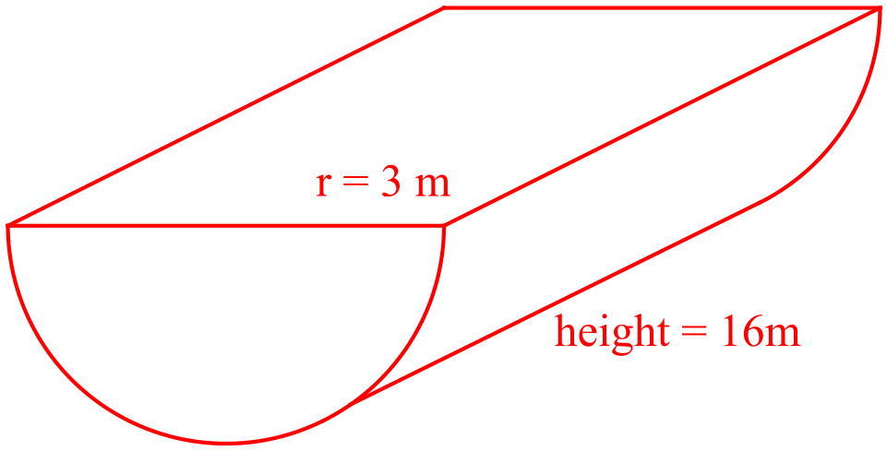  ✓ | ✓  ✓  ✓  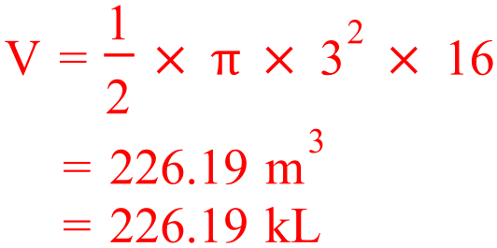

11. | [5 marks: 2, 3]
 | Milk is taken from a dairy farm to a processing plant in large ‘tank trucks’. The tank on the truck is a large cylinder that has a diameter of 2.3 m and a height of 8.5 m. At the processing plant, the milk is transferred into small tanks. These tanks are also cylindrical in shape, with a diameter of 1.8 m and a height of 4.7 m. After treatment, the milk is poured from these tanks into 500-mL cartons.
a) | Calculate the volume of the tank on the truck, in m³. Round your answer to two decimal places.
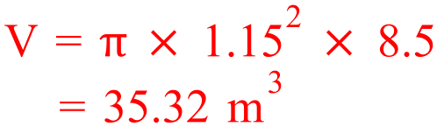

✓
✓

b) | Calculate how many of the smaller tanks at the processing plant could be filled from one tank truckload.
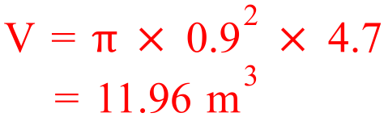

✓
✓

✓

12. | [3 marks]
 | A roof has an area of 120 m². The rain that falls onto the roof runs into a tank with a volume of 10 m³. What depth of rain needs to fall onto the roof to completely fill the tank? Give your answer in millimetres, correct to one decimal place.
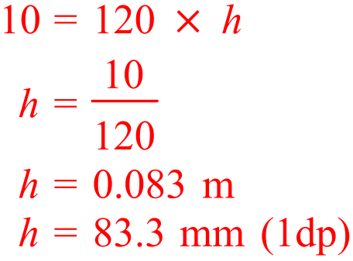
✓
✓

13. | [4 marks]
Josh and Jenna decide to camping for the Easter long weekend. They purchased a new tent in the shape of a triangular prism for the occasion, and they are hoping that the weather is fine as the tent is not waterproof.

The packaging for the tent states that the base of the tent is 8 m by 10 m, and the volume is 88 m³.

Josh is worried that the tent is not tall enough for him to stand up in.

If Josh is 1.9 m, will he be able to stand up in the tent?

Draw a diagram to represent the situation and show full working out to justify your answer.
 | 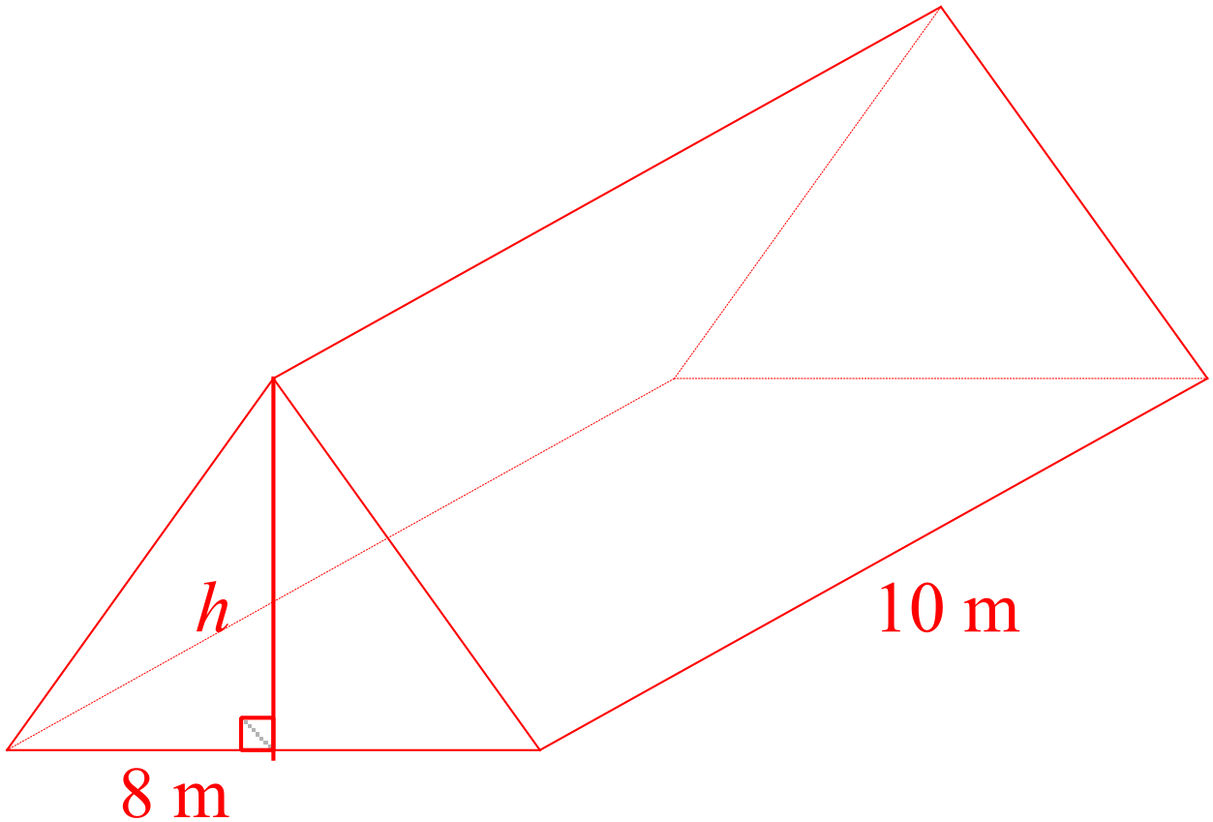✓
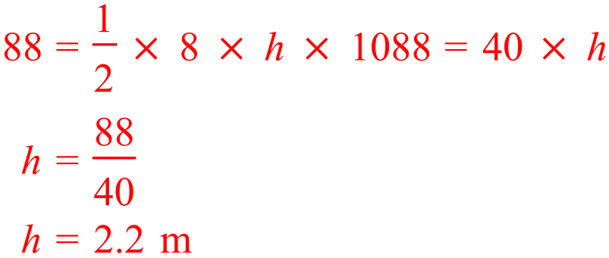
✓

✓

 | As the height of the tent is greater than 1.9 m, Josh can stand up in the tent. ✓

~ END OF TEST SECTION 2 ~

